# RadRichTextBox for Winforms

**Overview**

The RichTextBox control offers broad editing and formatting capabilities with unmatched performance and true Word-like experience. The control allows import and export of Html, Docx, and Xaml and multiple Undo/Redo feature.



* **Microsoft Word-like Text Editing and Formatting**

The new Telerik RichTextBox control allows you to edit text and apply rich formatting options, like:

* + Bold, Italic
  + Underline, Strike Through
  + Built-in fonts and sizes
  + Text color and background
  + Bullet and numbered lists
  + Paragraph alignment and indentation
  + Show/Hide formatting symbols
  + Clear Formatting
  + Support for inline Images
  + Line and Page-breaks support
  + Predefined Page sizes and margins and paragraph indents
  + Various underline styles

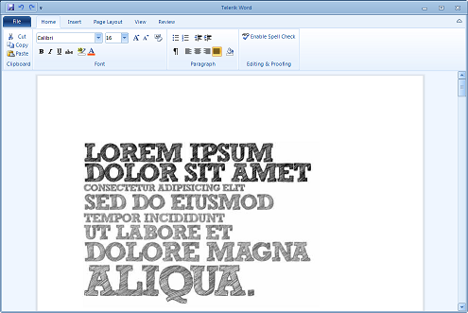

* **Import /Export**

With Telerik Winforms RichTextBox control you can load XAML (rich-text), HTML and Docs formats into the control, format and edit them and then export it back to plain text or XAML formats.